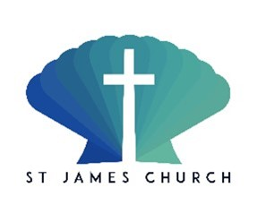
Gift Aid Declaration for past present and future donations
Name of Charity: St James the Great Church Downley
Details of donor:
Title……..Forename(s)…………………………… Surname………………………………………………..
Address
….………………………………………………………………………………………………………………….. …………………………………………….
Post Code…………………………………………………….
I want the charity to treat as Gift Aid donations all qualifying gifts of money made
Today The past four years In the future
Please tick all boxes you wish to apply
I confirm that I have paid or will pay an amount of Income Tax and/or Capital Gains Tax for each tax year (6 April to 5 April) that is at least equal to the amount of tax that all the charities or Community Amateur Sports Clubs (CASCs) that I donate to will reclaim on my gifts for that tax year. I understand that other taxes such as VAT and Council Tax do not qualify. I understand the charity will reclaim 25p of tax on every £1 that I give.
Signature............................................................................... Date………./………./……….
NOTES
1. You can cancel this Declaration at any time by notifying the charity.
2. If in the future your circumstances change and you no longer pay tax on your income and capital gains equal to the tax that the charity reclaims, you can cancel your declaration.
3. If you pay tax at the higher rate you can claim further tax relief in your Self Assessment tax return.
4. If you are unsure whether your donations qualify for Gift Aid tax relief, ask the charity. Or, refer to donations by individuals.
5. Please notify the charity if you change your name or address.

